AI ASS 9.1
Name: J.Yeshwanth Reddy
H.T.NO:2303A52270
Batch:43

Problem 1:
Consider a Python function find_max(numbers) that returns the maximum value from a list. Write documentation for this function using docstring, inline comments, and Google-style documentation.
Compare the three documentation styles by discussing their advantages, disadvantages, and suitable use cases.
Finally, recommend the most appropriate documentation style for a mathematical utilities library with justification.
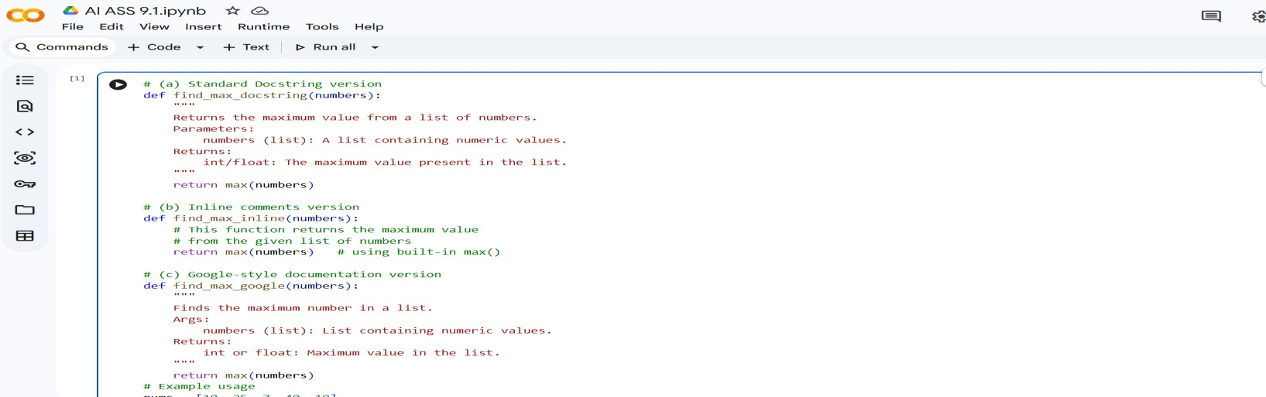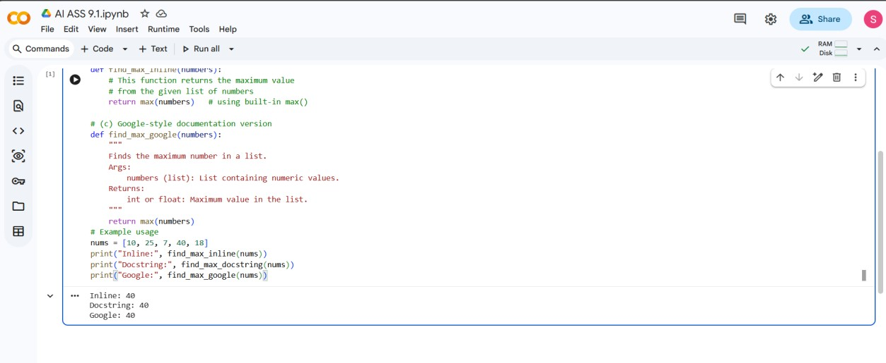
Problem 2:
Consider the Python function login(user, password, credentials) that checks whether a username and password match a stored dictionary of credentials. Write documentation for this function in three formats: inline comments, standard docstring, and Google-style documentation.
Compare the three approaches by discussing their advantages, disadvantages, and suitable use cases.
Finally, recommend which documentation style is most effective for helping new developers onboard a project, and justify your choice.
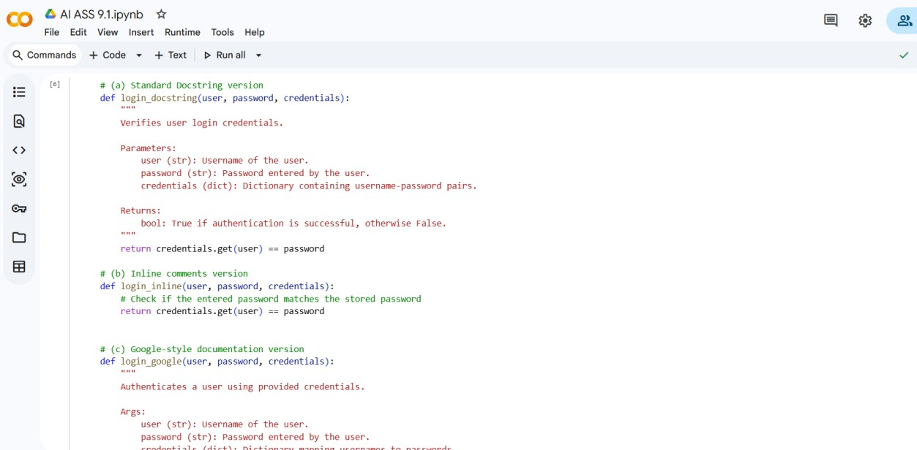

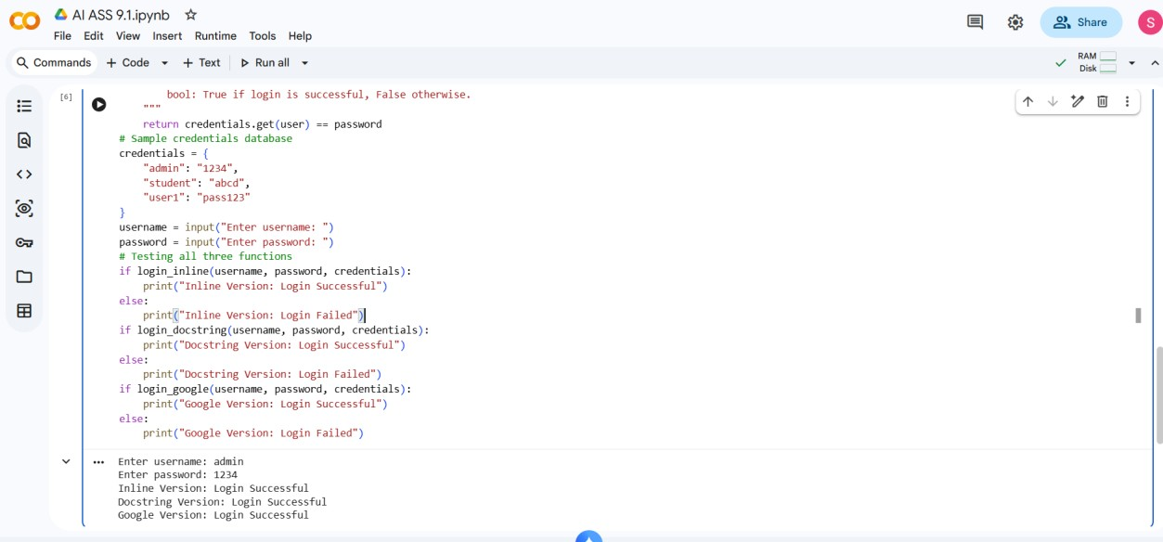
Problem 3:
Design a Python module named calculator.py that provides basic arithmetic functions: add(a, b), subtract(a, b), multiply(a, b), and divide(a, b).
Write appropriate docstrings for each function.
Demonstrate automatic documentation generation by displaying the module and function docstrings in the terminal using Python’s documentation tools. Also, generate and export the module documentation in HTML format using pydoc and verify it in a web browser.
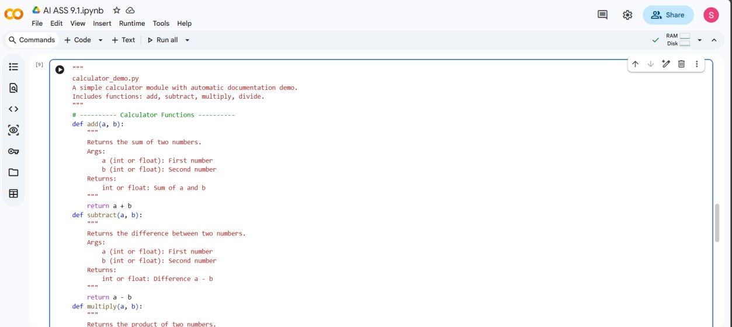

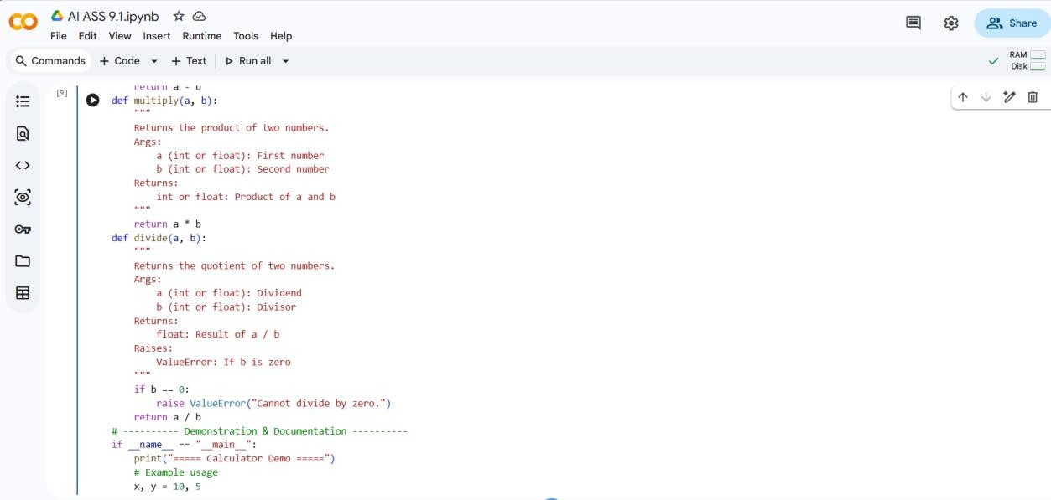

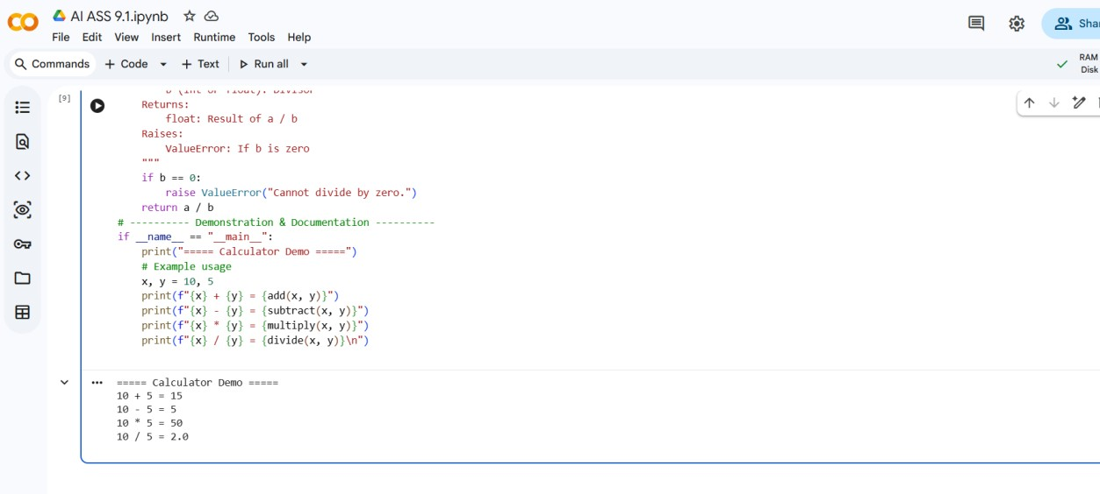
Problem 4:
1. Create a Python module named `conversion.py` that includes the following functions:
- `decimal_to_binary(n)` : Converts a decimal number `n` to its binary string representation.
- `binary_to_decimal(b)` : Converts a binary string `b` to its decimal number.
- `decimal_to_hexadecimal(n)` : Converts a decimal number `n` to its hexadecimal string representation.
- Add proper docstrings for each function (use Copilot or AI for autogeneration if needed).
- Generate documentation for the module in the terminal using Python's builtin tools.
- Export the documentation to HTML format and open it in a browser.
Extra:
- Include a test block that demonstrates all three conversions.
- Ensure the script is self-contained, so running it executes the tests and opens the documentation.

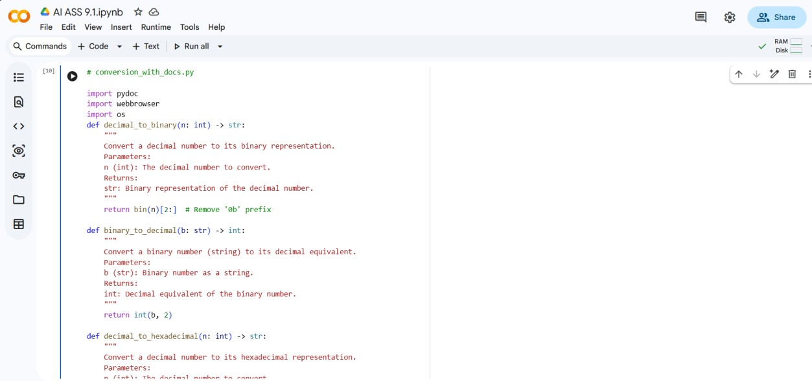

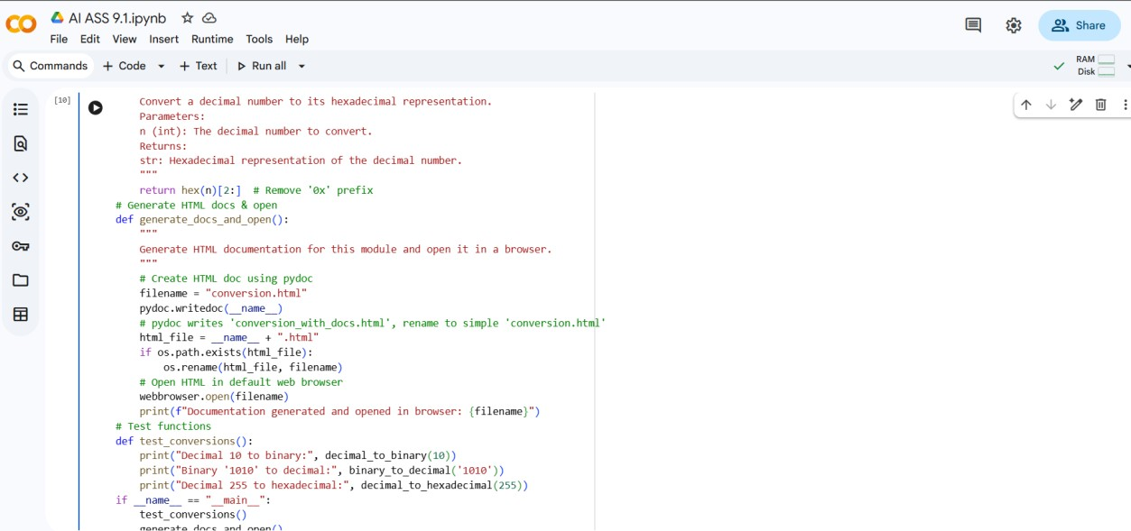

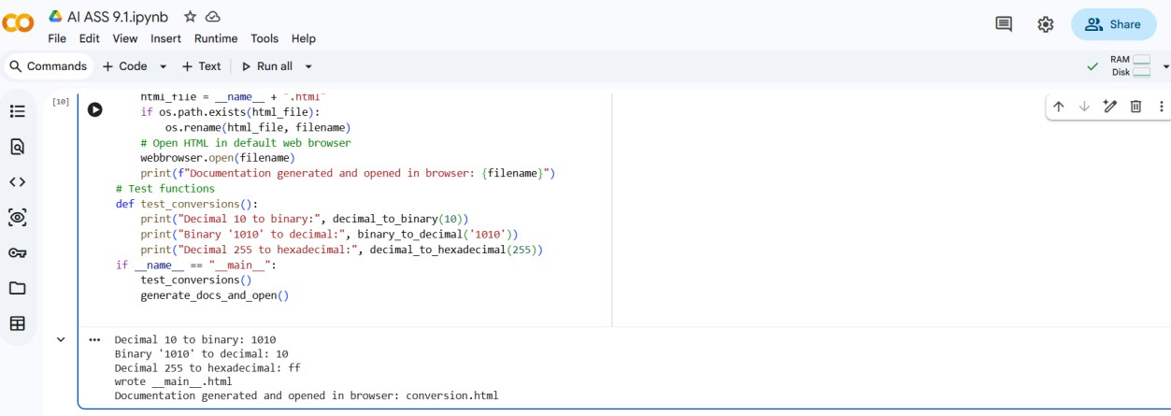
Problem 5:
1. Create a Python module named `course_with_docs.py` that includes the following functions:
- `add_course(course_id, name, credits)` : Adds a course to an internal course dictionary.
- `remove_course(course_id)` : Removes a course by its ID and returns True if removed, False if not found.
- `get_course(course_id)` : Returns the course details as a dictionary if found, else None.
- Add proper docstrings for each function (use Copilot or AI for autogeneration).
- Include a test function that demonstrates adding, retrieving, and removing courses.
- Generate HTML documentation for the module using Python's built-in `pydoc`.
- Automatically open the HTML documentation in the default web browser..
